**3. Perform OLAP operations**

1. Drill Down-Analyze sales data at a more detailed level. Write a query to perform drill down from region to product level to understand sales performance.

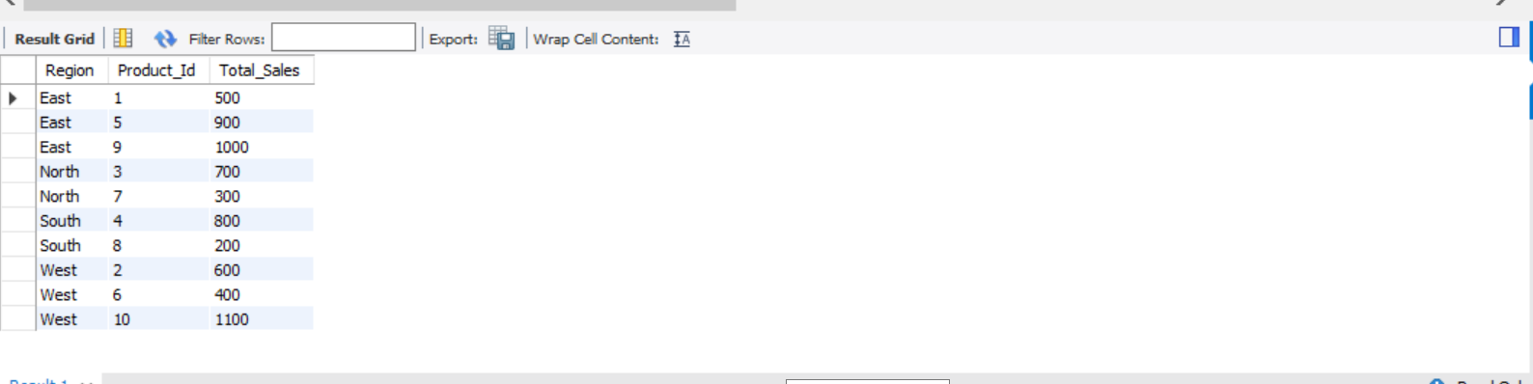

1. Rollup- To summarize sales data at different levels of granularity. Write a query to perform roll up from product to region level to view total sales by region.

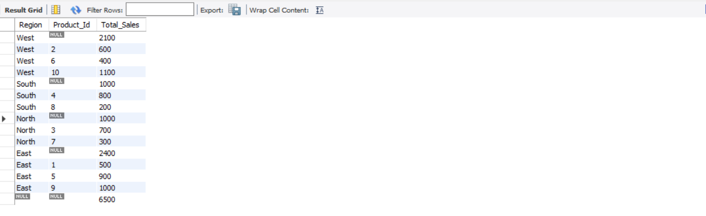

1. Cube - To analyze sales data from multiple dimensions simultaneously. Write a query to Explore sales data from different perspectives, such as product, region, and date.

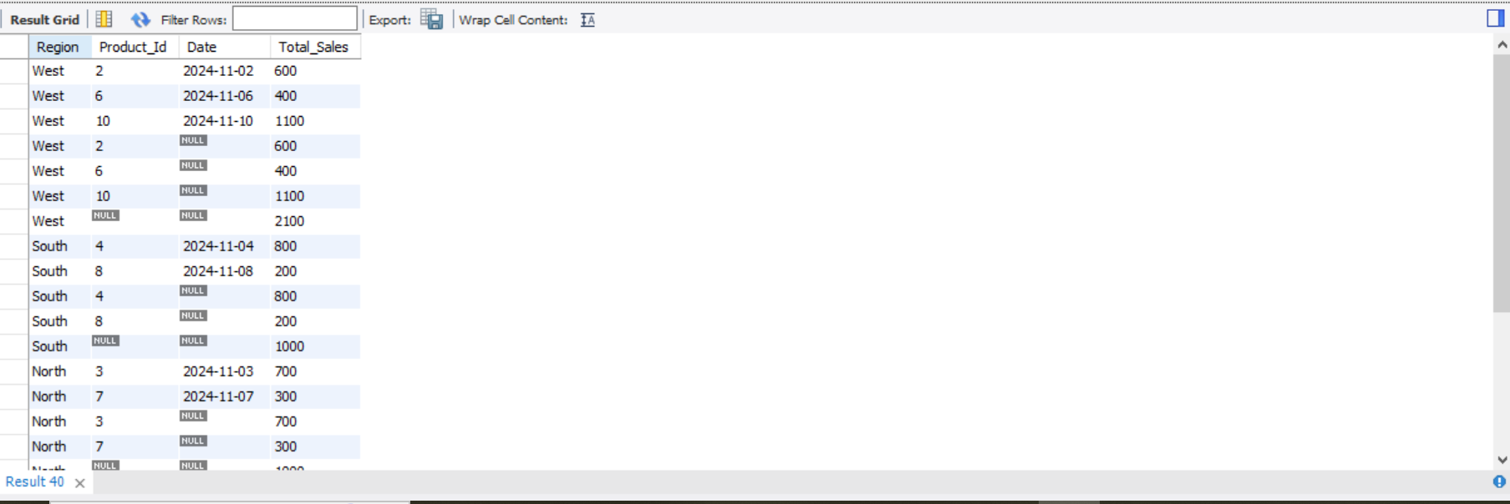

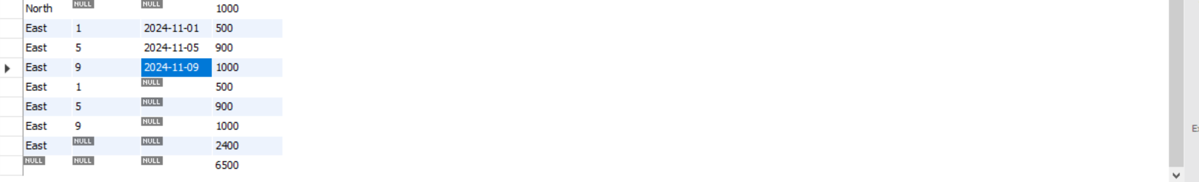

1. Slice- To extract a subset of data based on specific criteria. Write a query to slice the data to view sales for a particular region or date range.

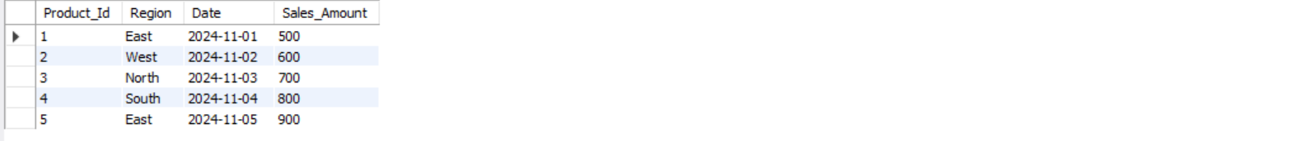

1. Dice - To extract data based on multiple criteria. Write a query to view sales for specific combinations of product, region, and date

